Directional Antonyms

🔹 What is Directional Antonyms
# Source: AI Source: Provided by: [Data Path: Persons Table -> ID Column: 1, Name_En Column: Motasem Essam] -> From: [Chatgpt (GPT-4-turbo)] on [7/30/2025]
Directional antonyms are word pairs that refer to opposite directions or orientations in space, movement, or position. They often describe physical or abstract directions that can be reversed.

🧠 Definition:
# Source: AI Source: Provided by: [Data Path: Persons Table -> ID Column: 1, Name_En Column: Motasem Essam] -> From: [Chatgpt (GPT-4-turbo)] on [7/30/2025]
Directional antonyms describe opposite directions in space, movement, or order and are often used in pairs that suggest a change or reversal.

📌 Key Characteristics:
# Source: AI Source: Provided by: [Data Path: Persons Table -> ID Column: 1, Name_En Column: Motasem Essam] -> From: [Chatgpt (GPT-4-turbo)] on [7/30/2025]
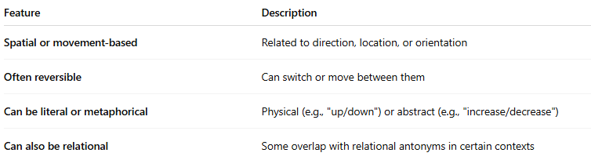
Feature | Description
Spatial or movement-based | Related to direction, location, or orientation
Often reversible | Can switch or move between them
Can be literal or metaphorical | Physical (e.g., "up/down") or abstract (e.g., "increase/decrease")
Can also be relational | Some overlap with relational antonyms in certain contexts

📚 Examples of Directional Antonym Pairs:
# Source: AI Source: Provided by: [Data Path: Persons Table -> ID Column: 1, Name_En Column: Motasem Essam] -> From: [Chatgpt (GPT-4-turbo)] on [7/30/2025]
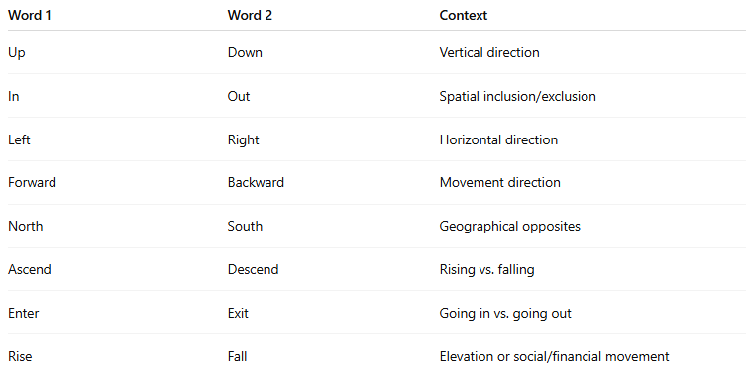
Word 1 | Word 2 | Context
Up | Down | Vertical direction
In | Out | Spatial inclusion/exclusion
Left | Right | Horizontal direction
Forward | Backward | Movement direction
North | South | Geographical opposites
Ascend | Descend | Rising vs. falling
Enter | Exit | Going in vs. going out
Rise | Fall | Elevation or social/financial movement

✏️ In Context:
# Source: AI Source: Provided by: [Data Path: Persons Table -> ID Column: 1, Name_En Column: Motasem Essam] -> From: [Chatgpt (GPT-4-turbo)] on [7/30/2025]
- The elevator is going up, but we need to go down to the lobby.
- She entered the room as he exited.

🔁 Comparison Table of Antonym Types:
# Source: AI Source: Provided by: [Data Path: Persons Table -> ID Column: 1, Name_En Column: Motasem Essam] -> From: [Chatgpt (GPT-4-turbo)] on [7/30/2025]
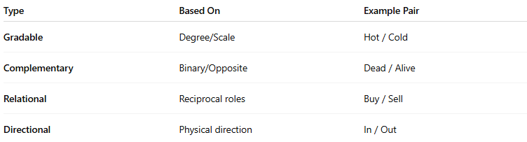
Type | Based On | Example Pair
Gradable | Degree/Scale | Hot / Cold
Complementary | Binary/Opposite | Dead / Alive
Relational | Reciprocal roles | Buy / Sell
Directional | Physical direction | In / Out

